Cloud Trail & Cloud Watch

1. Enable cloudtrail monitoring and store the events in s3 and cloudwatch log events.

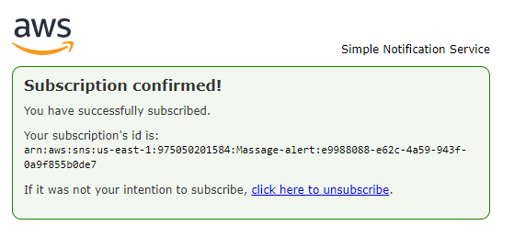

1. Enable SNS for cloudtrial to send alert on email.

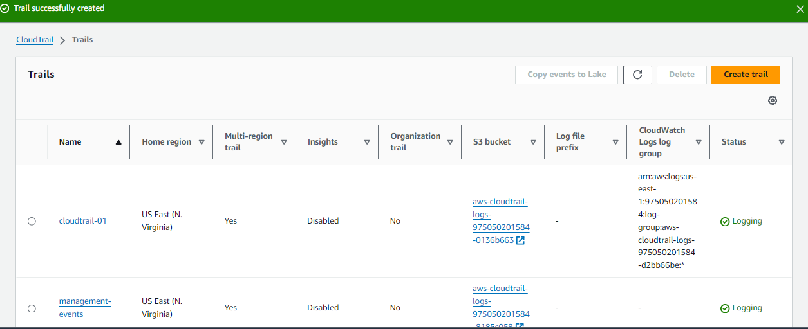

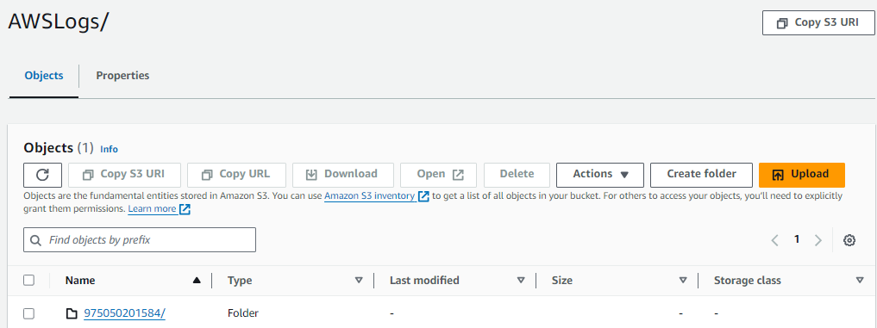

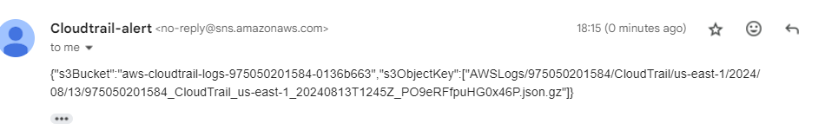

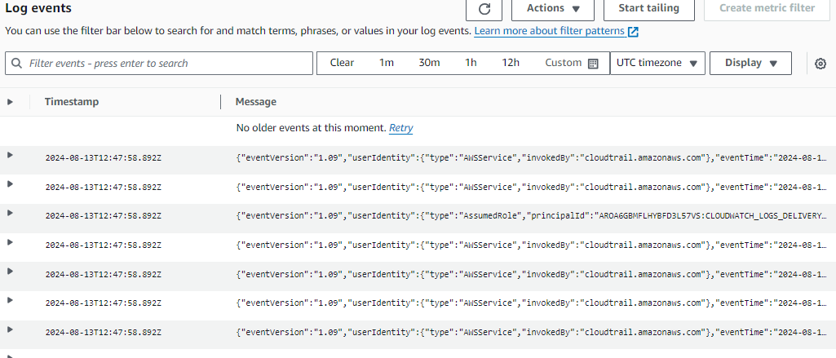

1. Configure cloud watch monitoring and record the cpu utilization and other metrics of ec2.

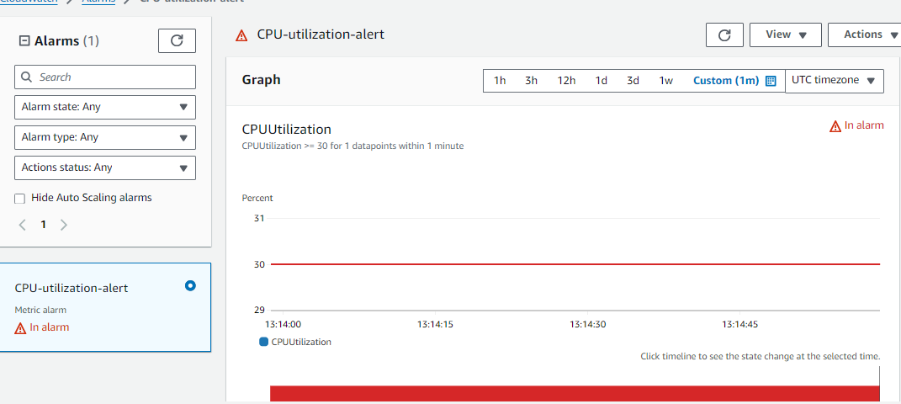

1. Create one alarm to send alert to email if the cpu utilization is more than 70 percent. 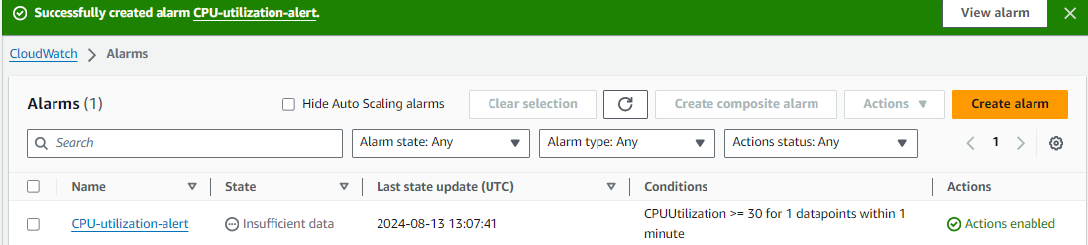
2. Create Dashboard and monitor tomcat service wether it is running or not and send the alert.

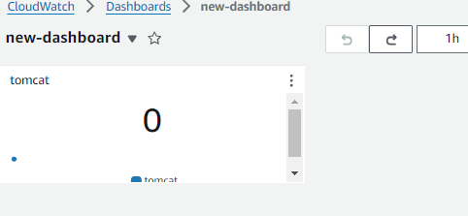

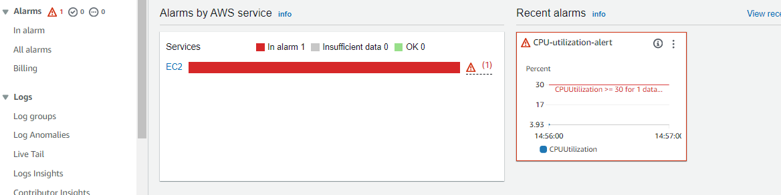

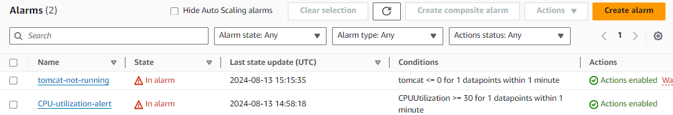

1. Create Dashboard and monitor nginx service to send the alert if nginx is not running.

